Geometrica: Shape Recognition Activity

Introduction
Welcome to Geometrica, an engaging and educational activity designed to help children recognise and identify basic geometric shapes, including triangles, circles, and squares. This activity provides an enjoyable environment where young learners can explore the world of geometry through observation and hands-on interaction.

Objectives
- Assist children in recognising common geometric shapes.
- Enhance visual perception and strengthen cognitive skills.
- Encourage observation and differentiation between various shapes.

Activity Overview
Geometrica offers a series of interactive tasks and playful challenges. These experiences motivate children to actively participate, making the process of learning about shapes both effective and entertaining.

Benefits
- Builds a strong foundation in basic geometry.
- Prepares learners for more advanced mathematical concepts in the future.

Activity consists of:
The use of the buttons on the MMS and the use of the accelerometer sensors on the MMS.
Time Code | Objective | Action to take | Correct action | Clip from video
1:10 | Touch the circle button with each circle seen in the picture | Press the circle button each time a circle is found | There are more that 4 circles. Expect more that 4 circle button presses. | 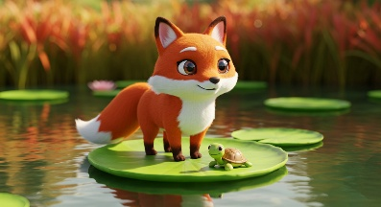
2:20 | Spot all the triangles in the picture | Press the triangle button each time a triangle is found | There are more that 16 triangles to be found. They are more difficult to spot. | 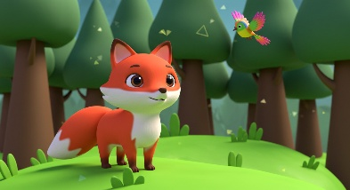
4:06 | Spot the rectangles | Press the square button for each rectangle that is identified | There are 3 rectangles. More can be identified if the trees are considered. It is also difficult as some of the rectangles are obscured. | 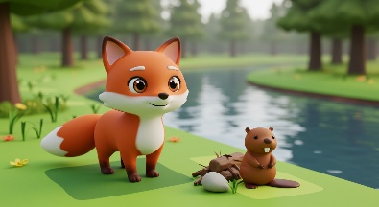
5:17 | Can you identify the new shape | Hold up your MMS if you can see it. * | As there is a clover in the picture it is expected that the accelerometer will show that it is held up. | 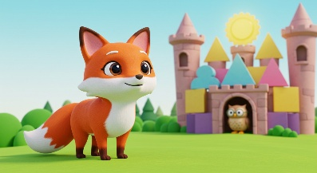
*The results will be presented as a plot. The Y-axis of the plot should display a deflection at the designated time code.
Young children should be able to identify basic shapes in various contexts, recognize multiple shapes in a picture, follow simple instructions, and understand expectations.

Conclusion
Geometrica is more than just an activity; it's an exciting journey into the world of shapes. By engaging in this activity, children will not only learn to recognize and differentiate between triangles, circles, and squares, but they will also enhance their visual perception and cognitive skills. The interactive tasks and playful challenges make learning enjoyable and effective, building a strong foundation in basic geometry. Let us embark on this exciting journey of shape discovery together and help children unlock the wonders of geometry!

